LSUHSC May 12, 2026, Staff Senate Minutes
2pm meeting, Lions Eye Center 632 and Zoom

Senators present included:

School of Allied Health
Angelica Bruno- Executive At Large
Wilbert Johnson

School of Dentistry
Michael Boutte
Michele Holmes
School of Graduate Studies
Cody Palazzolo - President Elect

School of Medicine
Brandi Donelon
Treva Durr
Cecilia Estep
Amy Gray
Patricia Oates- President
Louie Schneider
School of Nursing
Brian “Nic” Manuel
Dusty Pigg
School of Public Health
Carl Kluttz
Toya D. Shanklin
Division of the Vice Chancellor for Academic Affairs
Rashantis Gray
Tonika Lockhart Mackie
Dale Prince
Kresenda Raasch
Ivy StrongToya D. Shanklin
Divisions of the Vice Chancellor for Administration & Finance + Chancellor Admin
Jessica Riche
Kyle Walker- Secretary
Registered proxies included:
Pam Galindo-Proxy- Angelica Bruno
Troylyn Billew- Proxy- Patricia Oates

Senator Patty Oates called the Meeting to Order at 2:00pm

Invited Speakers / Special Presentations

Vice Chancellor for Academic Affairs
Kresenda Raasch read Dr. Porche’s report
- Board of Supervisors deadline for the September meeting is July 13.
- 3-year academic plans are due to VCAA May 20.
- School of Allied Health PA Self Study will be submitted this month.
- Dr. Dalton approved 90 nursing students for Baton Rouge site for Fall 2026 and 120 for spring 2027.
- Promotion & Tenure letters were signed by Dr. Dalton, received by VCAA on 5/5/26 and will be sent to recipients by May 15.
- Registrar position is posted, 28 applications came in, 9 were screened, and are interviewing with search committee.
- School of Public Health met with Taiwan delegation, and we may have a MOU in the works.

Vice Chancellor for Administration and Finance
Human Resources: Toastmasters presentation by Braylin Artigues, Associate Director

Supply Chain and Auxiliary Operations- Dining Services presentation and discussion by Brent Herold, Executive Director of Supply Chain and Auxiliary Operations
- A lack of volume results in limited services.
- 5 Star is the contracted service provider and can provide coffee service for a fee for departments that want to utilize the service.

Senator Kyle Walker motioned to approve the April 2026 minutes. The motion was seconded by Michael Boutte.

President's Report
- Senior Vice Chancellor of Academic Affairs/Provost interviews are wrapping up.
- LSU Baton Rouge Staff Senate is celebrating 50 years.

Committee Reports
- Communications –Co-Chair- Kyle Walker
  - Check the website for agendas, meeting minutes and event information. Thank you Ivy Strong for updating the website.
- Community Engagement and Development- Chair: Patty Oates
  - Discussing winetasting and polo shirt fundraisers.
  - Planning a School Supply drive for staff in July.
- Staff Advocacy and Retention- Chair: Michele Holmes
  - Added staff senate awareness material to the new employee orientation packet.
  - Working with HR to plan an annual staff remembrance.

New Business -Updates from LSUSHC Committees and Schools
- Faculty Senate- Michael Boutte
- DS renovations will begin soon
- Graduate Studies increased the stipend.
- Nursing is updating the curriculum

- Wellness Committee
    - Spring into Wellness Challenge was successful.
    - Wellness Center Fitness Fridays have begun.
    - There will be a Wellness Center in the DS 1st floor following the renovation.

- Hunger Free Campus workforce
    - Members changing due to retirements.
    - Food for Finals is wrapping up.
    - Back to School Health fair is August 19.
    - Food Pantry location will be added to the website.

- Schools
    - Nursing- OCIS in Baton Rouge is growing and hiring three staff positions.
    - Medicine is hiring three Business Manager 2’s.

- 2026 proposed constitutional amendment on the May 16 ballot
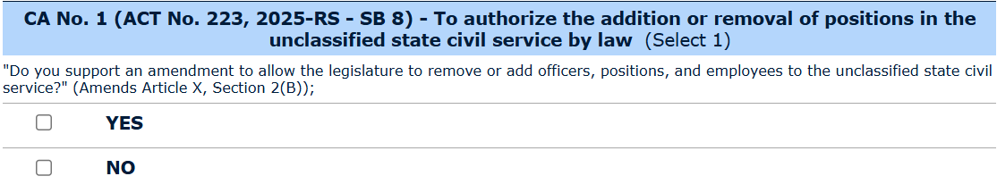
- Review the Civil Service website for information regarding the amendment.

- Open discussion:
- Increased remote days due to increased gas prices is not possible. Refer to CM73, the remote work policy.
- Changing payroll to twice a month for unclassified employees is a significant lift due to the existing 8 payroll processes.
- Contact Campus Federal Credit Union for assistance with developing a budget; managing cash flow and contacting creditors/bill payors to move payment dates.
- A salary adjustment for employees with 25 years of service is not possible. Equity is reviewed yearly by HR.
- Hurricane Season begins June 1. Sign up for LSUHSC-NO alerts.
- University Police will contact the employees that expressed interest in the self-defense class.
Meeting adjourned at 3pm by President Patty Oates.

